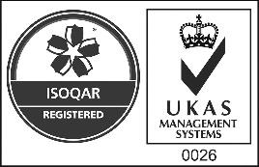

Certificate Number 0026

ISO 9001

OHSAS 18001

REQUEST FOR FREE LOAN FOR USE OF MOBILE BINS

--- NON-RESIDENTIAL CUSTOMERS --- ***Send via e-mail to*** [***infoa@sistemaambientelucca.it***](mailto:infoa@sistemaambientelucca.it)

Business name Legal seat in Via No. Place Prov Ph. email Contributor code VAT **Requests**



**The assignment on free loan for use of**

No. kit

No. Mobile bin for compost

120 L

240 L

360 L

No. Mobile bin for unsorted waste

120 L

240 L

360 L

Nr. Mobile bin for light multi-material

120 L

240 L

360 L

No. Mobile bin for glass

120 L

240 L

360 L

No. Mobile bin for paper

120 L

240 L

360 L

No with lock

lock/s (The cost of the lock is 18.24 € each) Please indicate which of the mobile bins

**and commits to**

* keep the bin(s) in good condition and use it exclusively for waste delivery;
* use the bin(s) in accordance with the instructions received and avoid damaging it/them;
* to return the bin(s) to Sistema Ambiente SpA, which remains the owner, in the event of any cause opposing the initiative;
* take note that Sistema Ambiente SpA may request the return of the bin(s) at any time, should it/they not be used in accordance with the intended purposes and methods.

Lucca

*(Stamps and legible signature)*

*Kit for Separate Waste Collection*

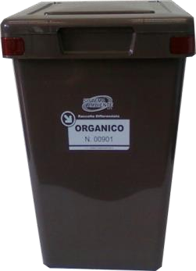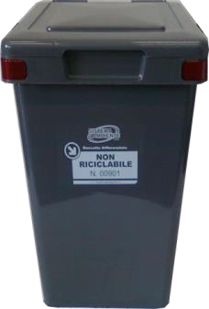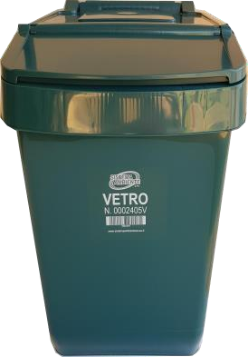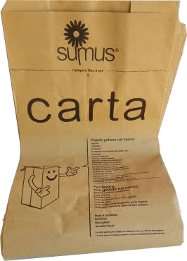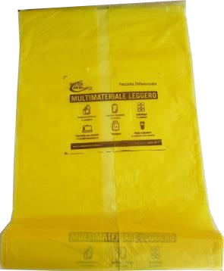

|  |  |  |  |  |
| --- | --- | --- | --- | --- |
| ***Compost*** | ***Unsorted waste*** | ***Glass*** | ***Bag for paper*** | ***Bag for*** |
| *25 L* | *25 L* | *25 L* |  | ***light multi-material*** |

*Types of mobile bins*

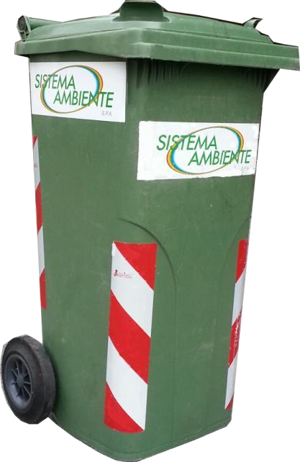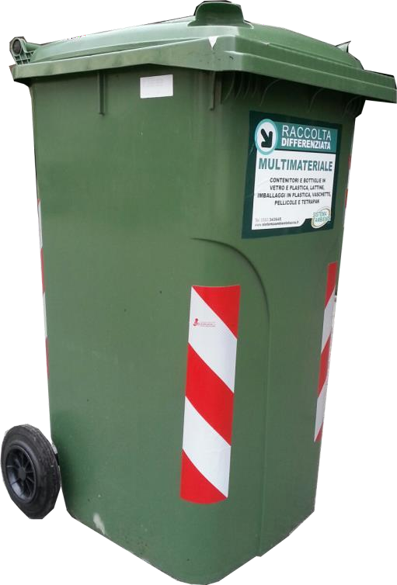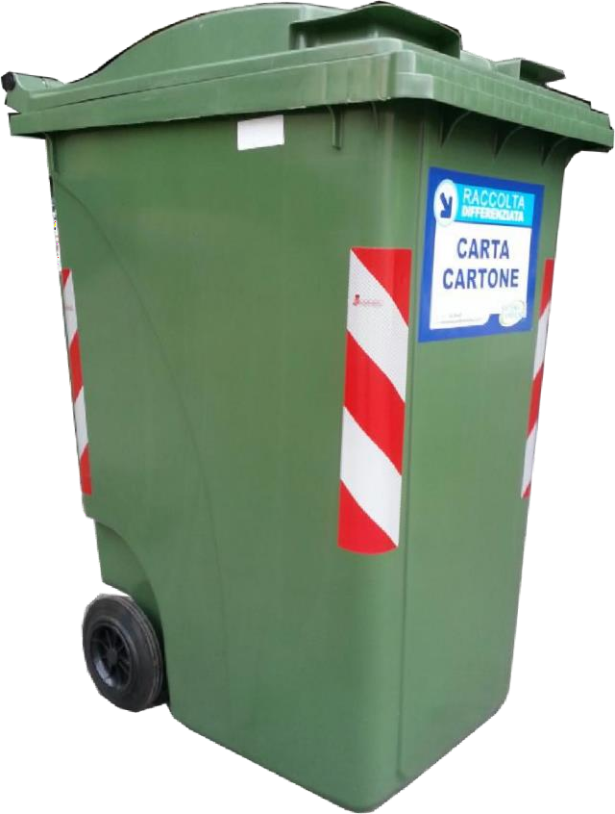

|  |  |  |
| --- | --- | --- |
| ***120 L***  *Size* | ***240 L***  *Size* | ***360 L***  *Size* |
| *W 50 x H 93 x D 54 cm* | *W 60 x H 103 x D 70 cm* | *W 60 x H 110 x D 88 cm* |

# >>> Next>>>>

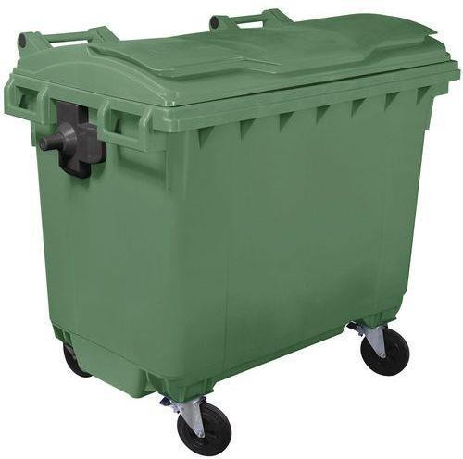

***660 L***

# Size

*W 137 x H 123 x D 78 cm*