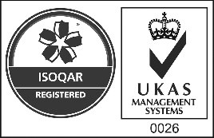

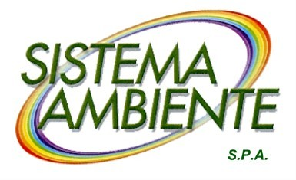Certificate Number 0026

ISO 9001

OHSAS 18001

REQUEST FOR FREE USE

GARDEN CUTTINGS BINS – NON RESIDENTIAL CUSTOMERS

Business name

Legal seat in No.

Place Prov.

Ph. No. email

Contract No. VAT

**REQUESTS**



**assignment on free loan for use of**

Nr mobile bin for garden cuttings lt. 120 No. mobile bin for garden cuttings lt. 240

**and commits to**

* keep the wheeled bin(s) in good condition and use it exclusively for waste/cuttings delivery;
* use the bin(s) in accordance with the instructions received and avoid damaging it/them;
* to return the bin(s) to Sistema Ambiente SpA, which remains the owner, in the event of any cause opposing the initiative;
* take note that Sistema Ambiente SpA may request the return of the bin(s) at any time, should it/they not be used in accordance with the intended purposes and methods.
* the bin will be delivered by Sistema Ambiente, subject to telephone agreement, at the indicated location.

As of 1 January 2019, the rates for the garden cuttings collection service have been changed as shown in the table below:

|  |  |
| --- | --- |
| **BIN L.** | **TARIFF** |
| 120 | €. 1.00 per month |
| 240 | €. 2.00 per month |

Users, who already use the service, can opt out by notifying Sistema Ambiente

S.p.A. by 30.09.2019, using the previous rate of €. 1.00 per month, regardless of the container capacity.

**Lucca**

(Legible signature)

Information on the processing of personal data on the website [www.sistemaambientelucca.it/it/privacy](http://www.sistemaambientelucca.it/it/privacy) - For information [privacy@sistemaambientelucca.it](mailto:privacy@sistemaambientelucca.it)

Pursuant to and for the purposes of Art. 76 of Italian Presid. Decree 445/2000, aware that anyone issuing false and misleading declarations or making use of them shall be punished in accordance with the Criminal Code and the special laws on the subject.